Name – Utkarsh Yadav

Roll – 23053172

DS Lab Assignment 1

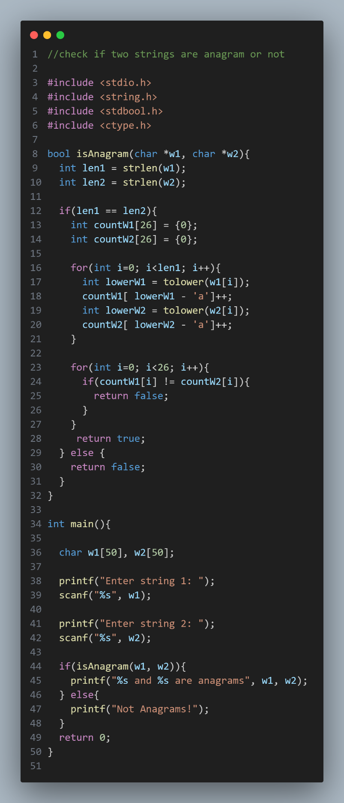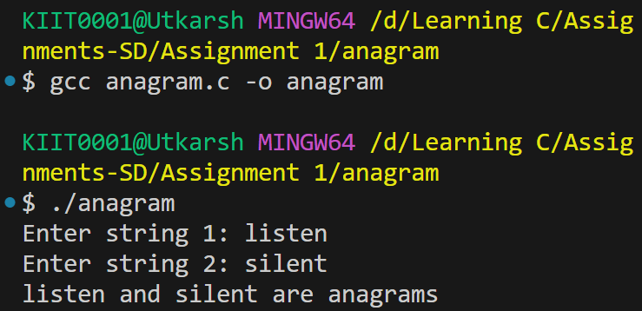

Implement a function that checks if two given strings are anagrams of each other. Ignore spaces and capitalization. For example, "Listen" and "Silent" are anagrams.

Implement a function to rotate an array of integers by 'k' positions to the right. For example, if the array is [1, 2, 3, 4, 5, 6, 7] and k is 3, the array should be modified to [5, 6, 7, 1, 2, 3, 4].

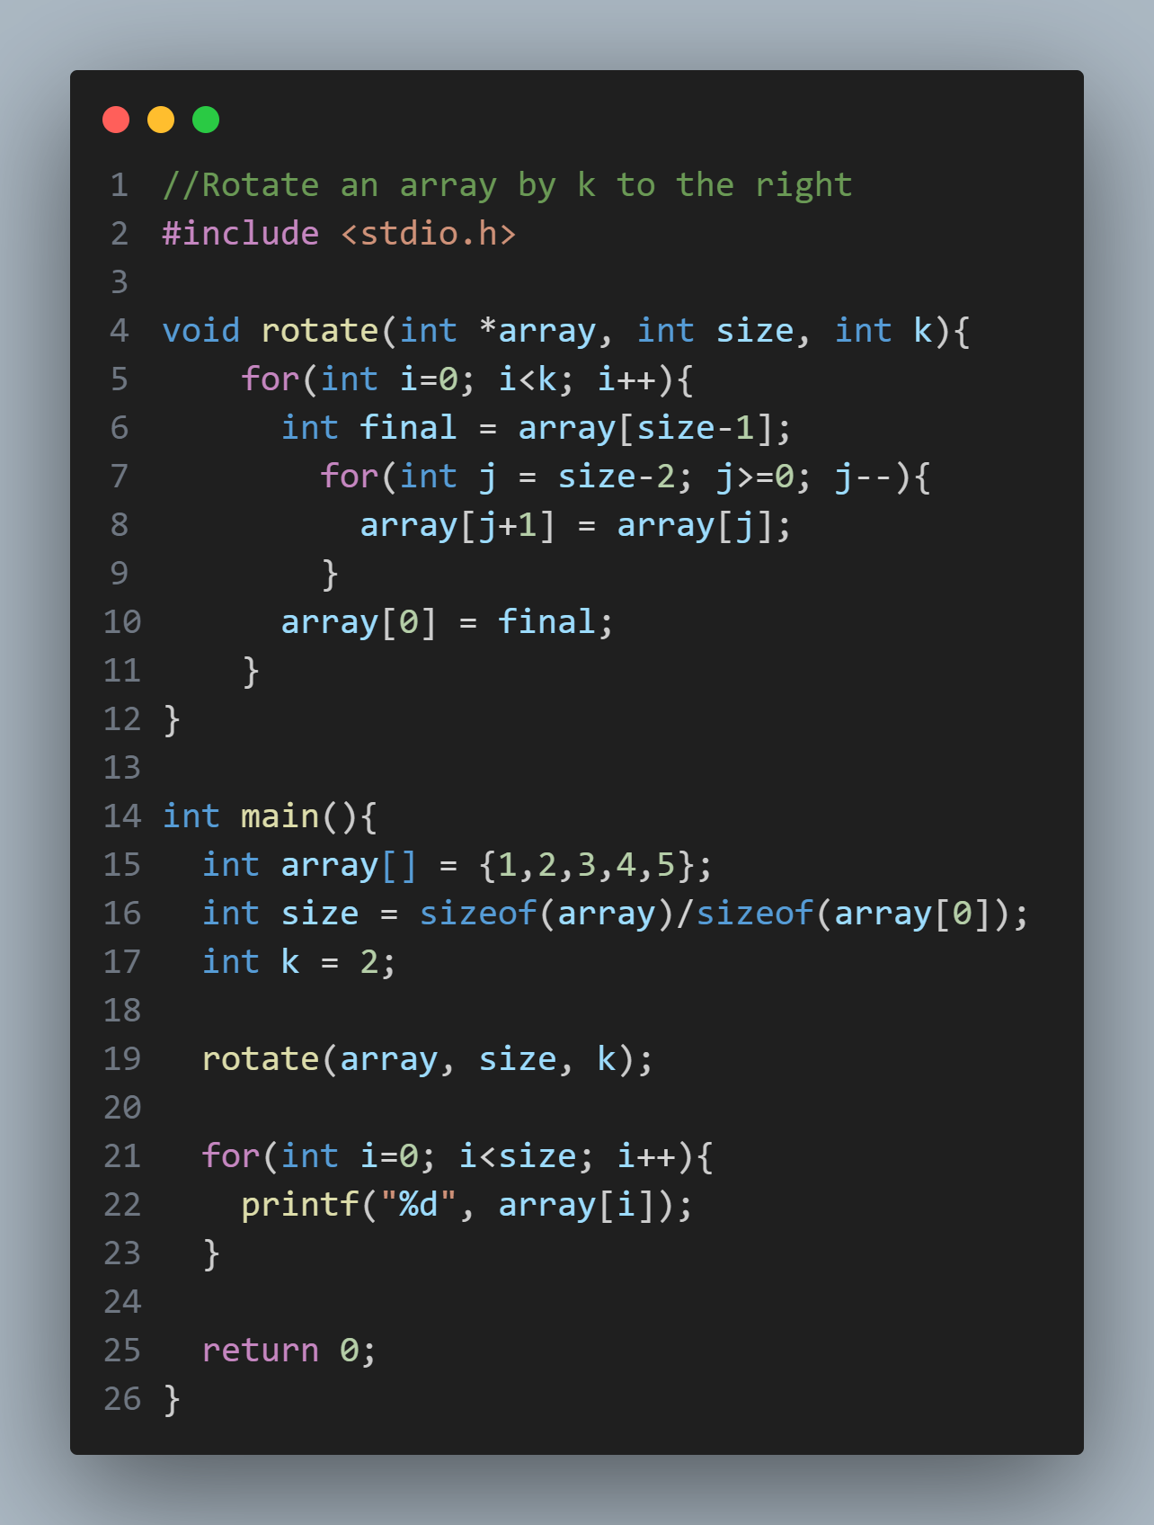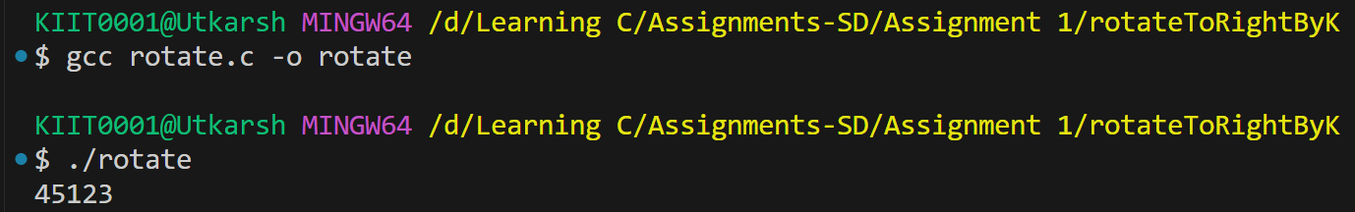

Create a program that intentionally causes a memory leak by allocating memory and not freeing it. Then modify the program to fix the memory leak and explain the changes made.

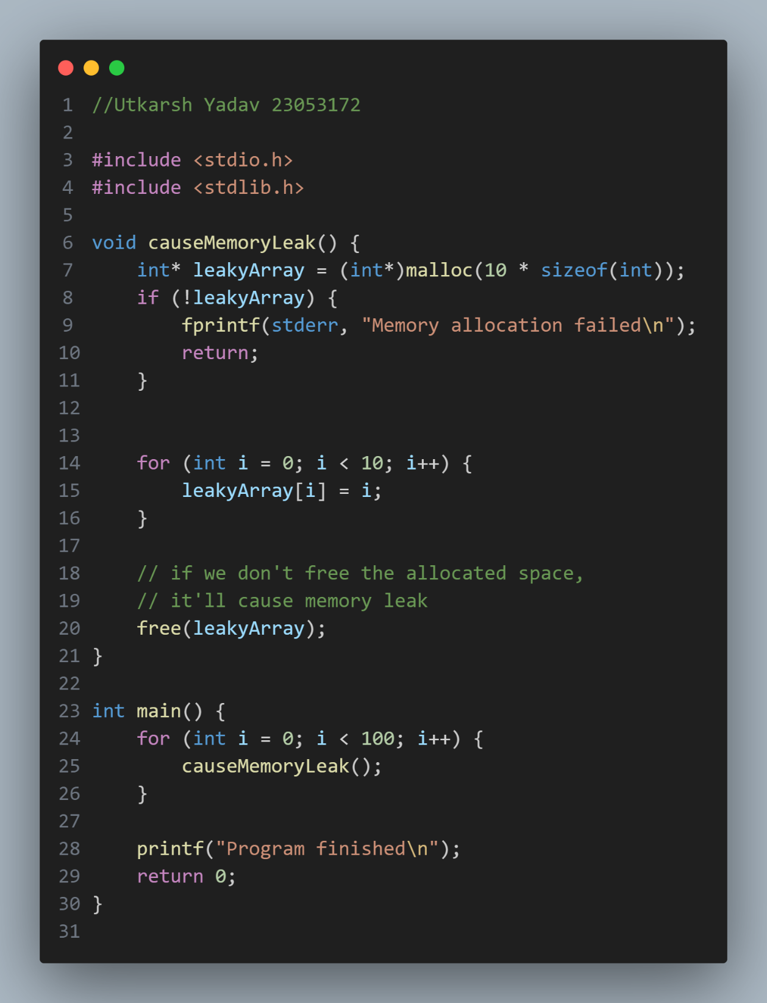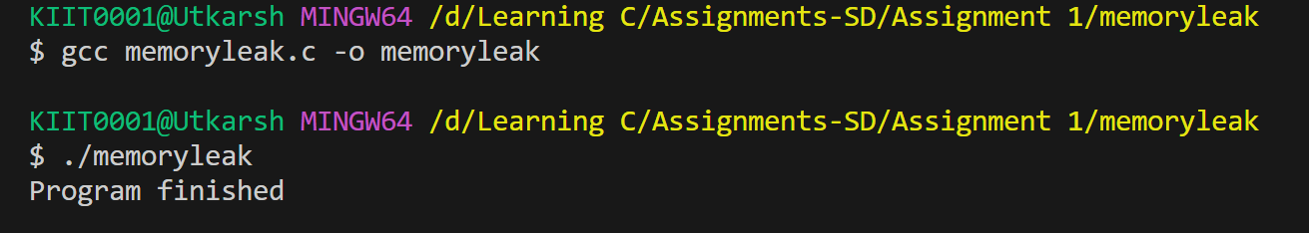

Implement a function to create a dynamic 2D array (matrix) using pointers. Provide functions to fill the matrix with values, print the matrix, and free the allocated memory.

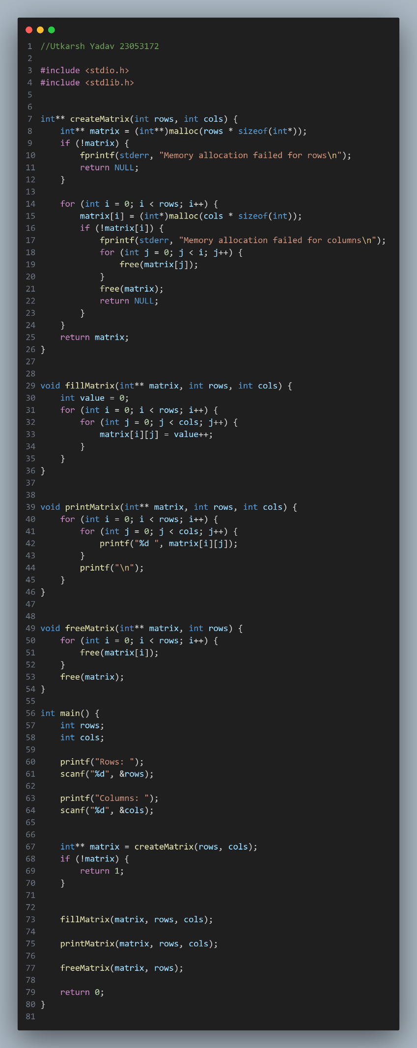

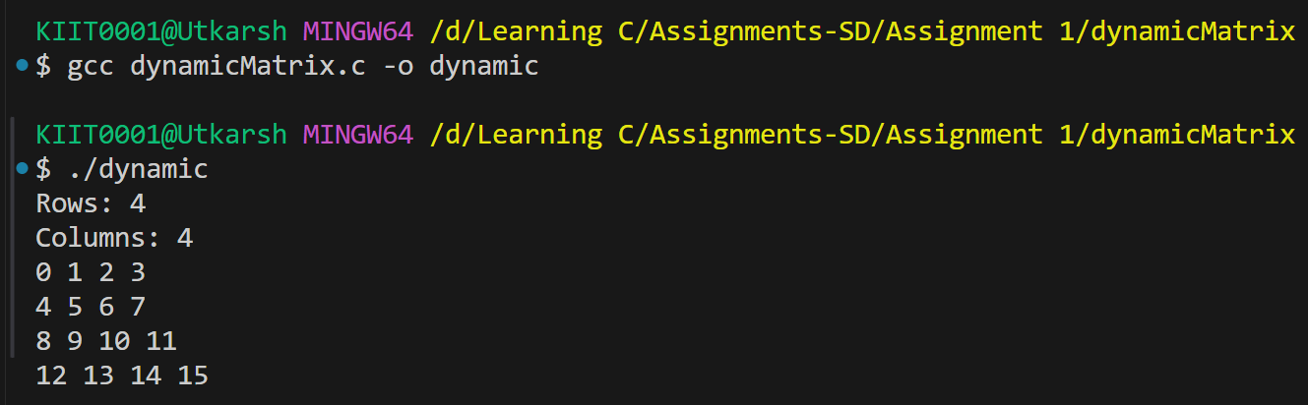

Write a function that accepts a pointer to an integer array and its size, then uses pointer arithmetic to reverse the array in place.

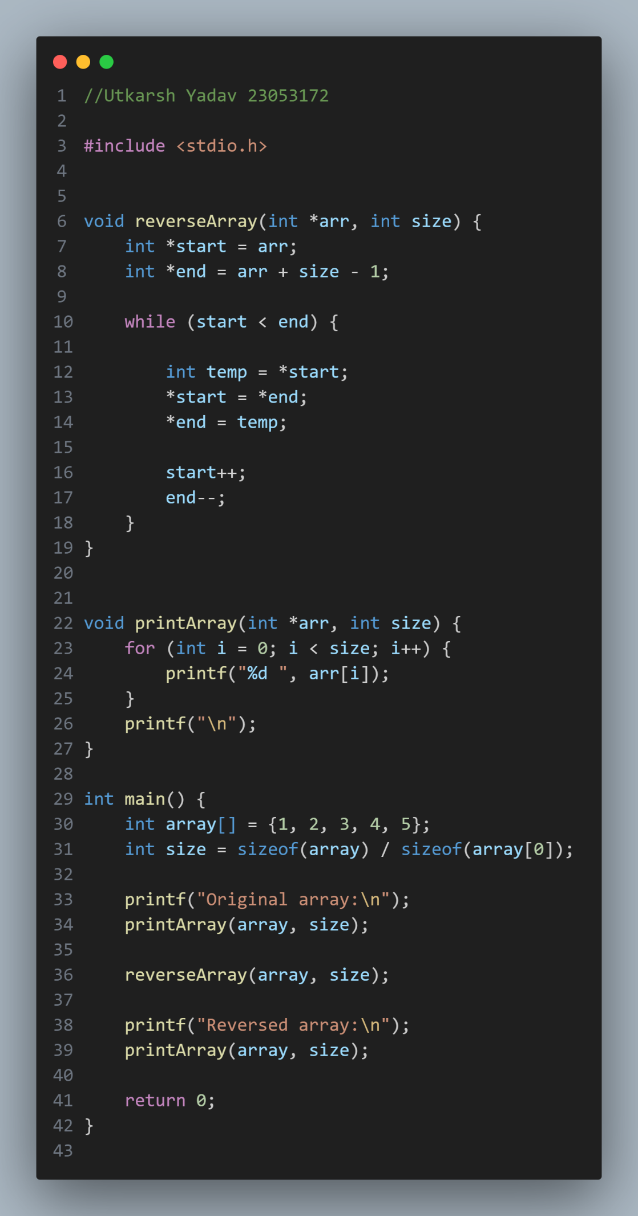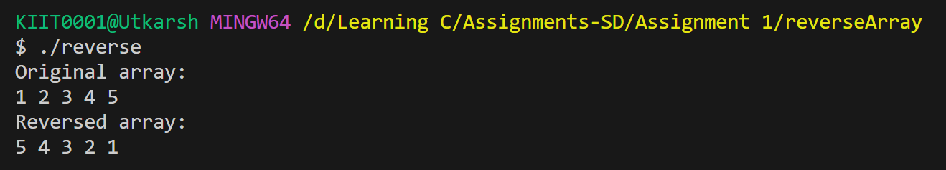

I tried to do the rest but couldn’t as I have run out of time and I don’t know how to do them. I’ll make sure to learn and do the rest as soon as possible.